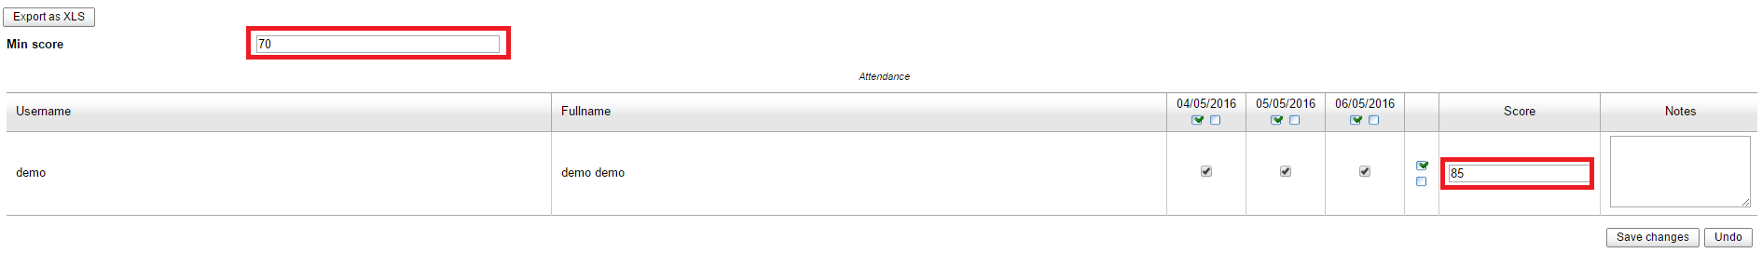
In the Attendance section, I have set a Min score and assigned a score to a user.
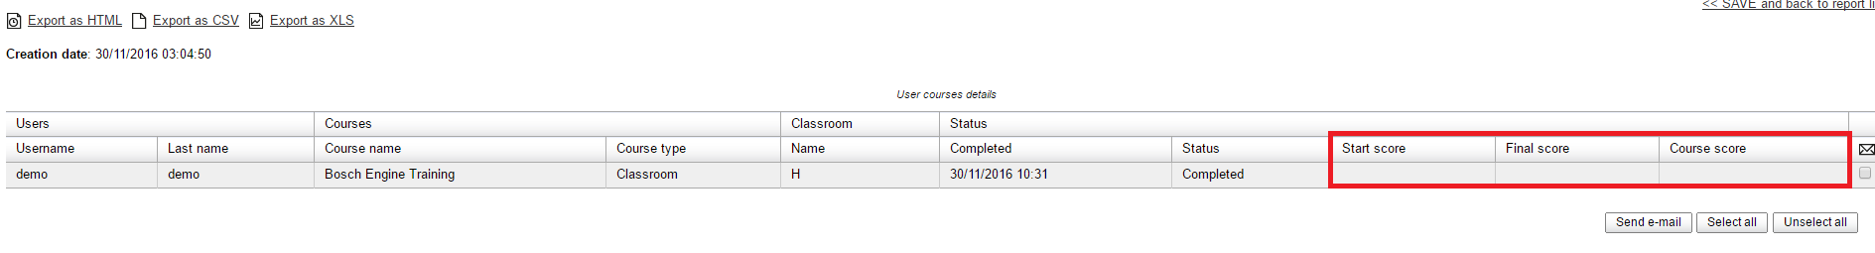
But the score does not show in the report.

